**Python Programming Assignment 01**

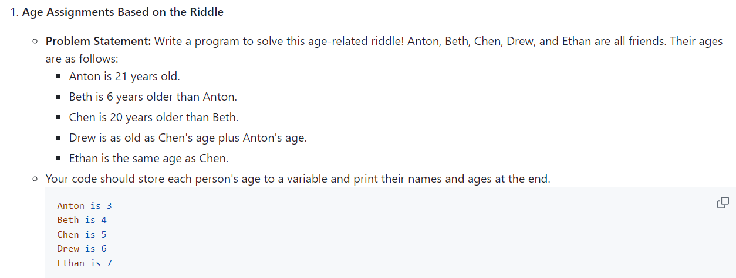

# Age Assignments Based on the Riddle

# Given age of Anton

anton_age : int = 21

# Calculate ages based on the given relationships

beth_age : int = anton_age + 6

chen_age : int = beth_age + 20

drew_age : int = chen_age + anton_age

ethan_age : int = chen_age

# Output the results

print(f"Anton is {anton_age}")

print(f"Beth is {beth_age}")

print(f"Chen is {chen_age}")

print(f"Drew is {drew_age}")

print(f"Ethan is {ethan_age}")

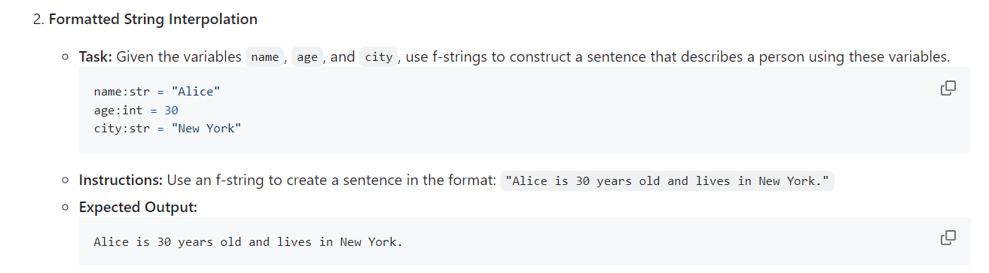

# Formatted String Interpolation

name : str = "Alice"

age : int = 30

city : str = "New York"

# Construct the sentence using an f-string

sentence : str = f"{name} is {age} years old and lives in {city}."

# Output the result

print(sentence)

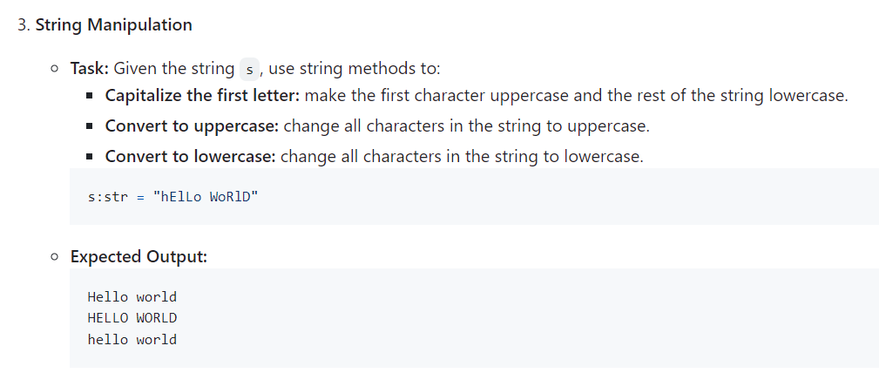

# String Manipulation

s:str = "hElLo WoRlD"

# Capitalize the first letter (first character uppercase, rest lowercase)

capitalized = s.capitalize()

# Convert the entire string to uppercase

uppercase = s.upper()

# Convert the entire string to lowercase

lowercase = s.lower()

# Output the results

print("Capitalized: ", capitalized)

print("Uppercase: ", uppercase)

print("Lowercase: ", lowercase)

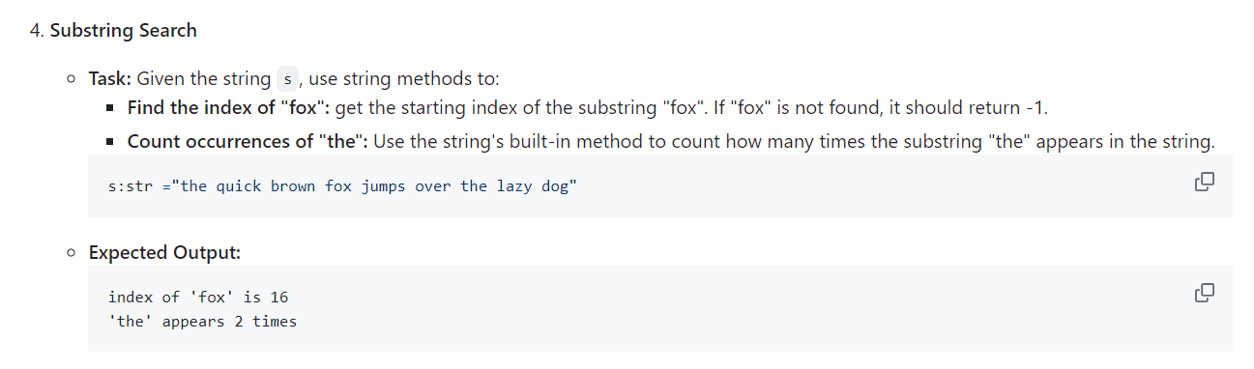

# Substring Search

s:str ="the quick brown fox jumps over the lazy dog"

# Find the index of "fox"

index_of_fox : int = s.find("fox")

# Count occurrences of "the"

count_of_the : int = s.count("the")

# Output the results

print(f"index of 'fox' is {index_of_fox}")

print(f"'the' appears {count_of_the} times")

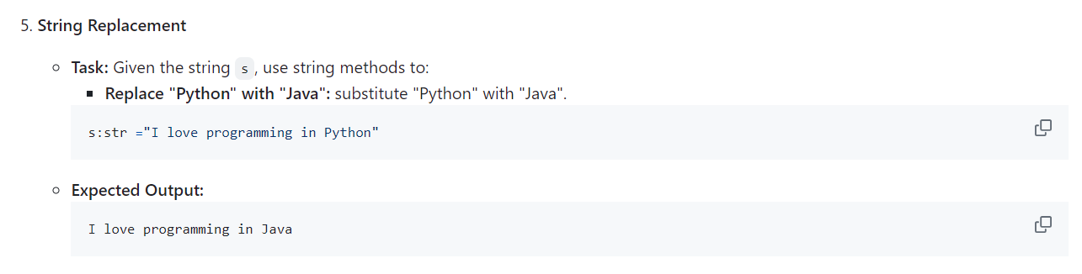

# String Replacement

s:str ="I love programming in Python"

# Replace "Python" with "Java"

substitute_sentence : str = s.replace("Python", "Java")

# Output the result

print(substitute_sentence)

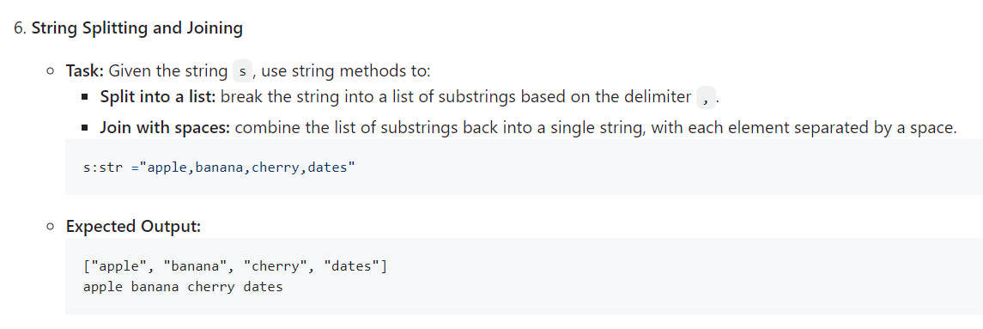

# String Splitting and Joining

s:str ="apple,banana,cherry,dates"

# break the string into a list of substrings based on the delimiter ,

s_list : list[str] = s.split(",")

# combine the list of substrings back into a single string, with each element separated by a space

s_joined : str = " ".join(s_list)

# Output the results

print(s_list)

print(s_joined)

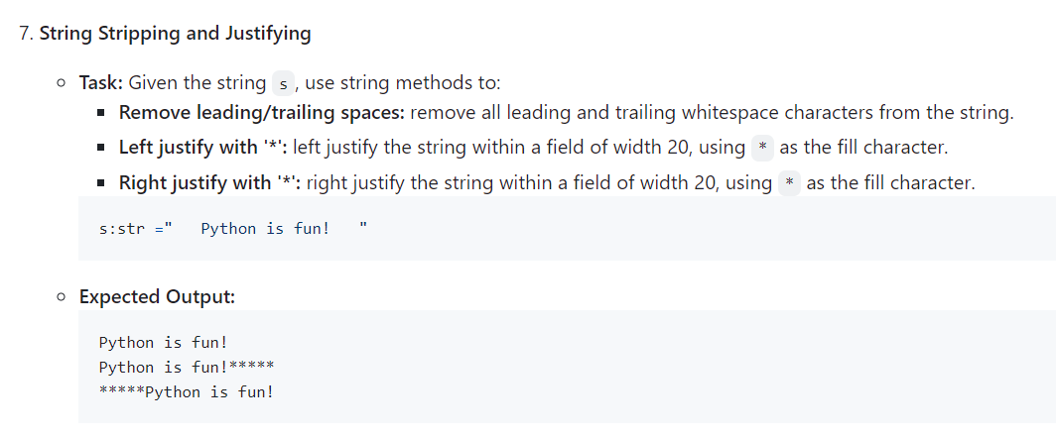

# String Stripping and Justifying

s:str ="   Python is fun!   "

# Remove leading and trailing spaces

s_trimmed : str = s.strip()

# left justify the string within a field of width 20, using * as the fill character

s_left_justified : str = s_trimmed.ljust(20, '*')

# right justify the string within a field of width 20, using * as the fill character

s_right_justified : str = s_trimmed.rjust(20, '*')

# Output the results

print(s_trimmed)

print(s_left_justified)

print(s_right_justified)

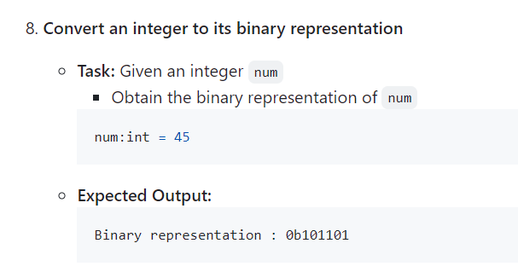

# Convert an integer to its binary representation

num : int = 45

# Get the binary representation of the number

binary_representation : str = bin(num)

# Output the result

print(f"Binary representation: {binary_representation}")

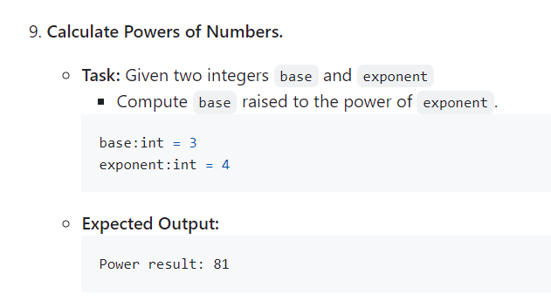

# Calculate Powers of Numbers.

base : int = 3

exponent : int = 4

# Calculate the power

power_result : int = base ** exponent

# Output the result

print(f"Power result: {power_result}")

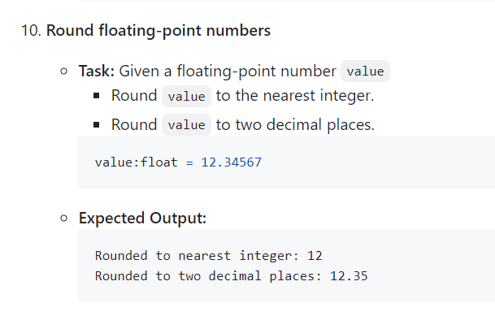

# Round floating-point numbers

value : float = 12.34567

# Round to the nearest integer

rounded_integer : int = round(value)

# Round to two decimal places

rounded_two_decimals : float = round(value, 2)

# Output the results

print(f"Rounded to nearest integer: {rounded_integer}")

print(f"Rounded to two decimal places: {rounded_two_decimals}")